Ideation Phase

Brainstorm & Idea Prioritization Template

|  |  |
| --- | --- |
| Date | 19 September 2022 |
| Team ID | PNT2022TMID54166 |
| Project Name | University Admit Eligiblity  Predictor |
| Maximum Marks | 4 Marks |

# Brainstorm & Idea Prioritization Template:

Brainstorming is a co operative approach in which a number of people collectively agree a solution after all the ideas are brought forth and discussed. Brainstorming provides a free and open environment that encourages everyone within a team to participate in the creative thinking process that leads to problem solving. The result is a broader range of ideas that may not have surfaced if teammates were to brainstorm collectively. Ideas are then shared at random with the rest of the group, who offer feedback and critique each idea. As an alternative, ideas can also be collected and sorted by a team leader or management team. The overlying goal of brainwriting is to separate idea generation from discussion. Prioritizing volume over value, out-of-the-box ideas are welcome and built upon, and all participants are encouraged to collaborate, helping each other develop a rich amount of creative solutions.

Use this template in your own brainstorming sessions so your team can unleash their imagination and start shaping concepts even if you're not sitting in the same room.

Reference: <https://www.mural.co/templates/empathy-map-canvas>

# Step-1: Team Gathering, Collaboration and Select the Problem Statement

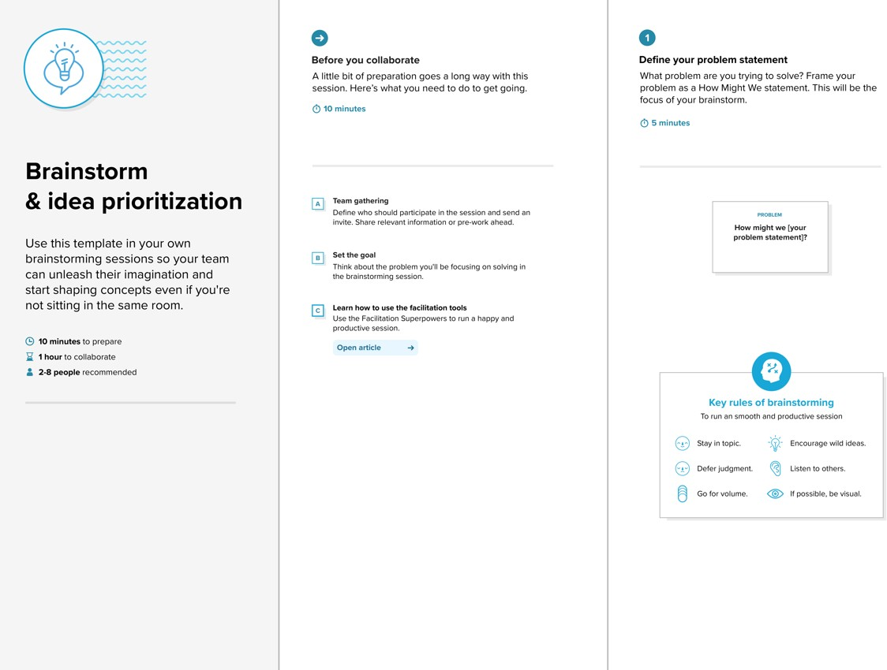

**Step-2: Brainstorm, Idea Listing and Grouping**

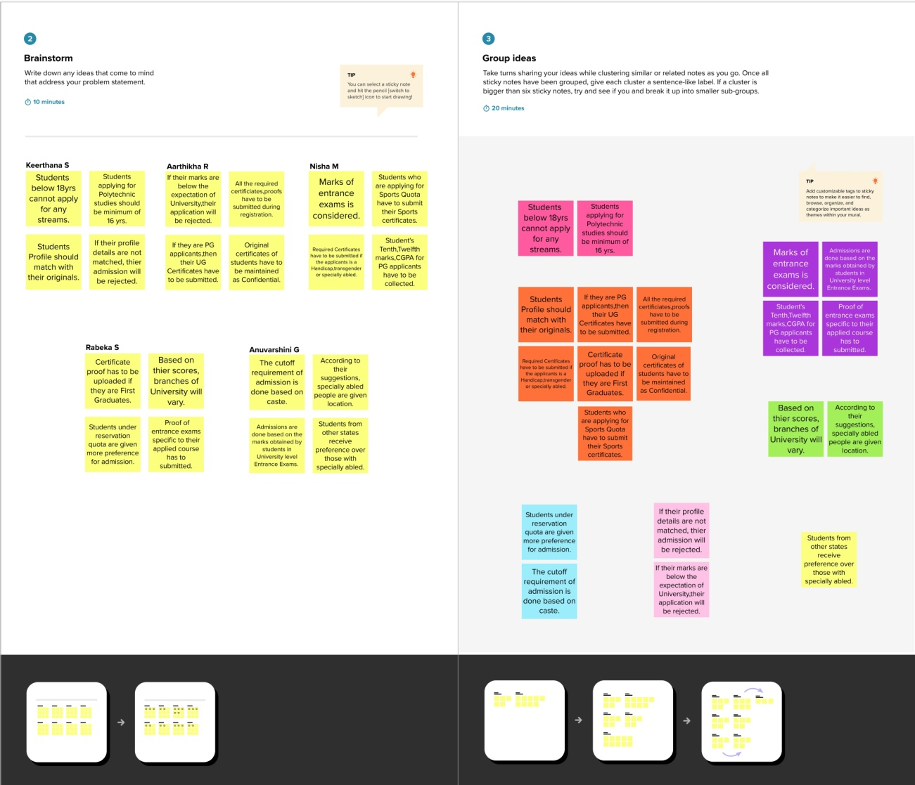

**Step-3: Idea Prioritization**

